DEPLOYMENT OF PYTHON APP IN AWS EC2 INSTANCES

An instance is a virtual server in the AWS Cloud. You launch an instance from an Amazon Machine

Image (AMI). The AMI provides the operating system, application server, and applications for your

instance.

So , I launch my AWS EC2 Instances naming it “Python_server” I choose the AMI in which I want

which is “ubuntu” which is the operating system (OS) for my instance.

Under **Instance type**, from the **Instance type** list, I select the hardware configuration for my

instance. Choose the t2.micro instance type, which is selected by default.

The t2.micro instance type is eligible for the free tier.

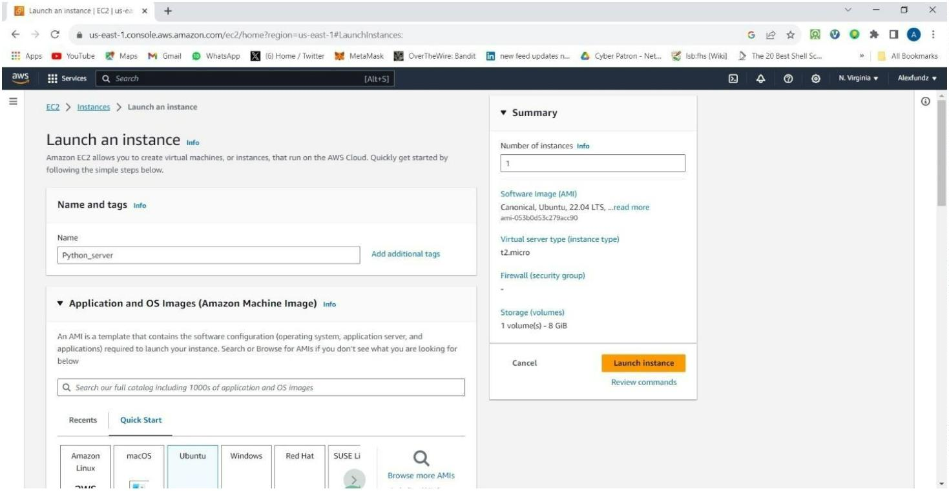

I used my already key pair and network security group in which I already created, then I created my

instances and then viewed it when it was lised

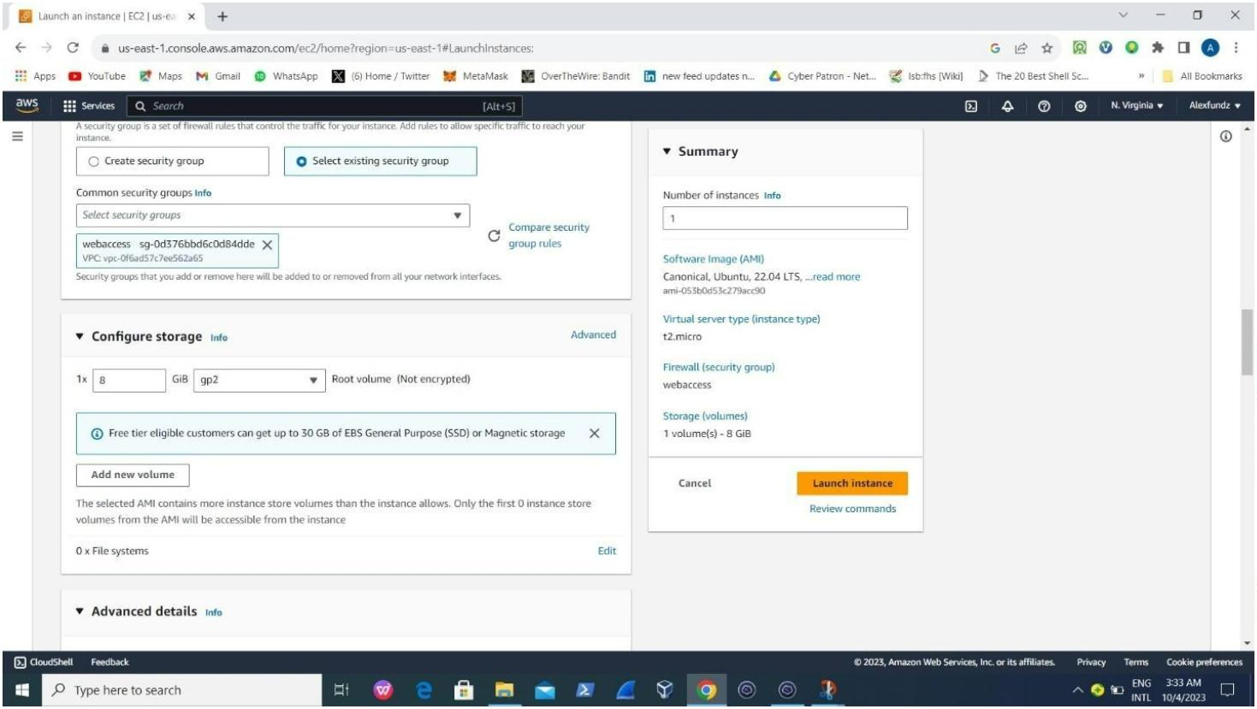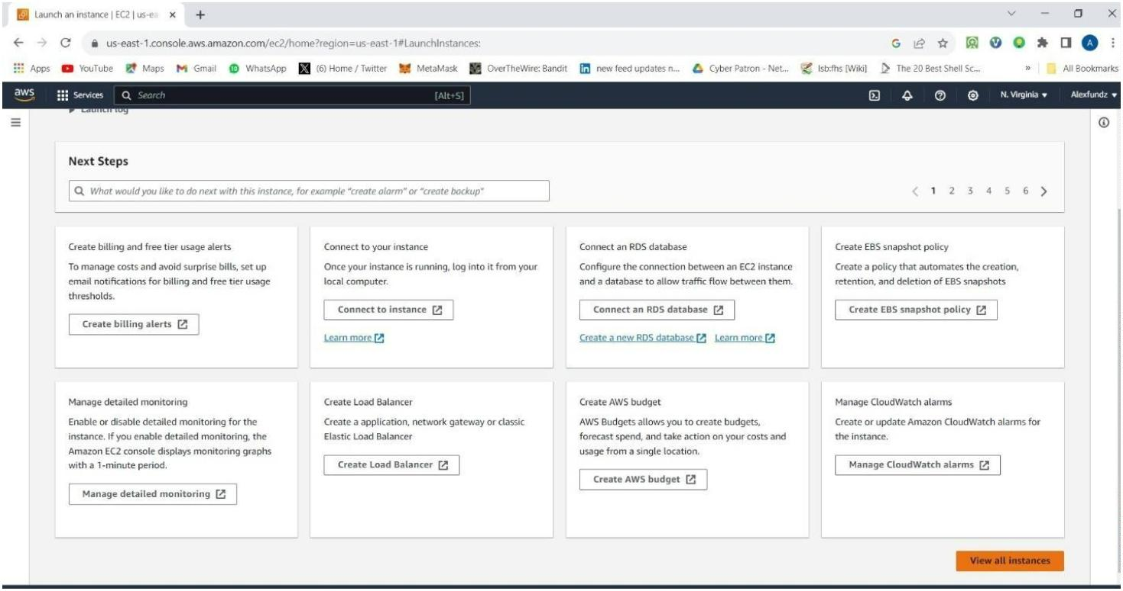

Aꢀer then, I connected my instances to an OS which I can control it from, the Os which is the Terminus

by copying my exisꢁng Public Ip address from the python_server ec2 instances I created which is

52.91.105.100

This is the server I created on terminus in which I linked my EC2 instance by linking using my username

which is “ubuntu” , Public ip address which is “52.91.105.100” and the key pair which is “Myprivate-key-mv-

pem”

Note : All are goꢂen from my AWS EC2 INSTANCES I CREATED….

Upon logging in to my Os which is coonected , I run “sudo apt update” , I created a directory to save the ﬁle

in which I want to deploy my python_app into and then I install git which is where I am going to copy the app

I want to deploy….

Pictures are aꢂached below :

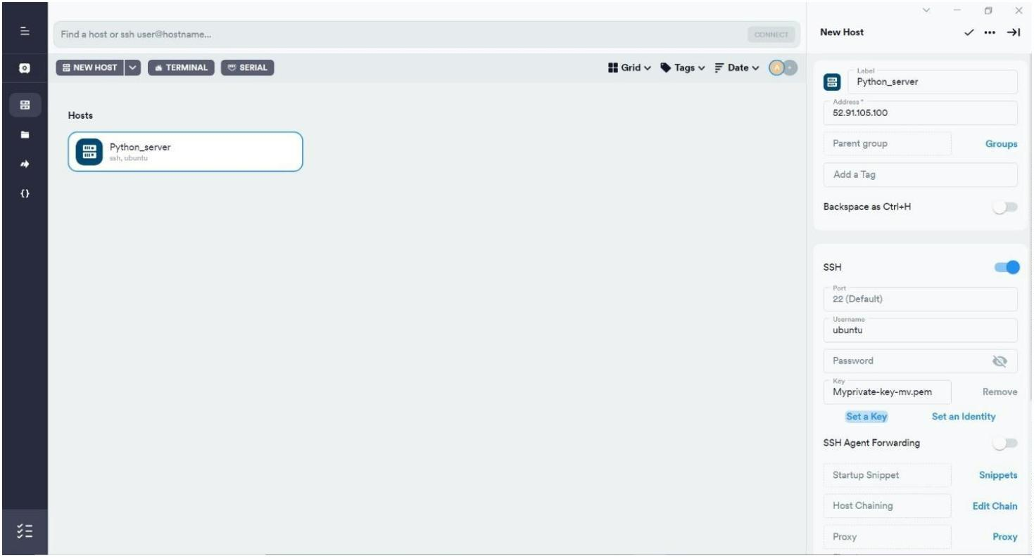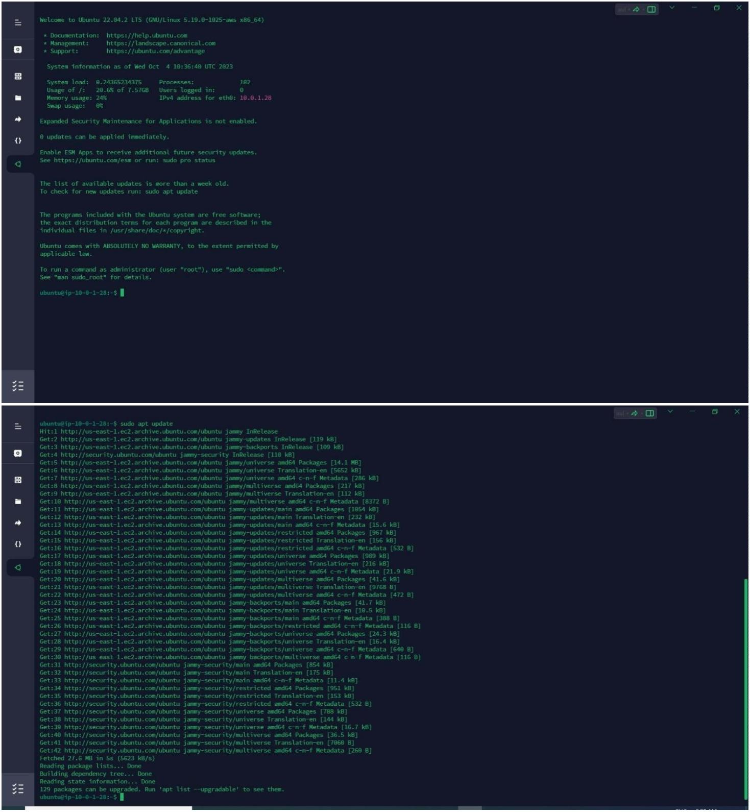

So , I needed to install the frame work in which python can work. So, I can run “sudo apt install python3”

which has already come with linux system

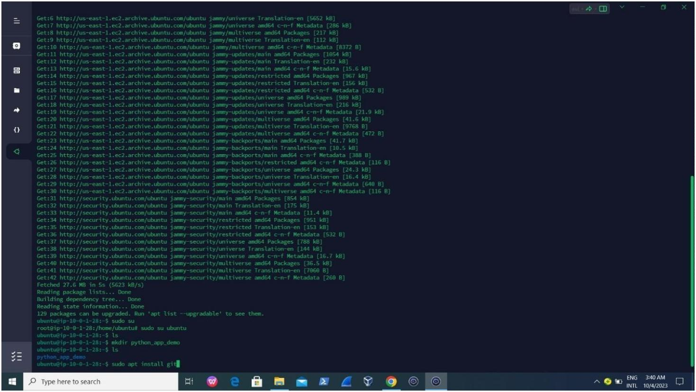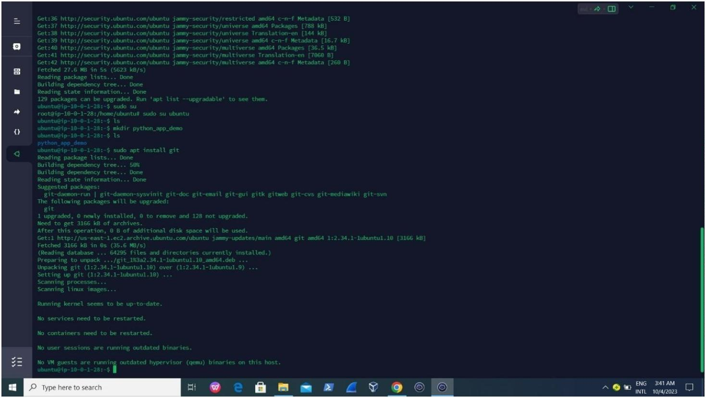

Aꢀer then I install “sudo apt install python3-pip.”

Then , I need to move to the directory in which I want to save the git repositories of the websites I want

to deploy… so , I press mkdir python_app_demo and I move to the directory by pressing cd

python_app_demo.

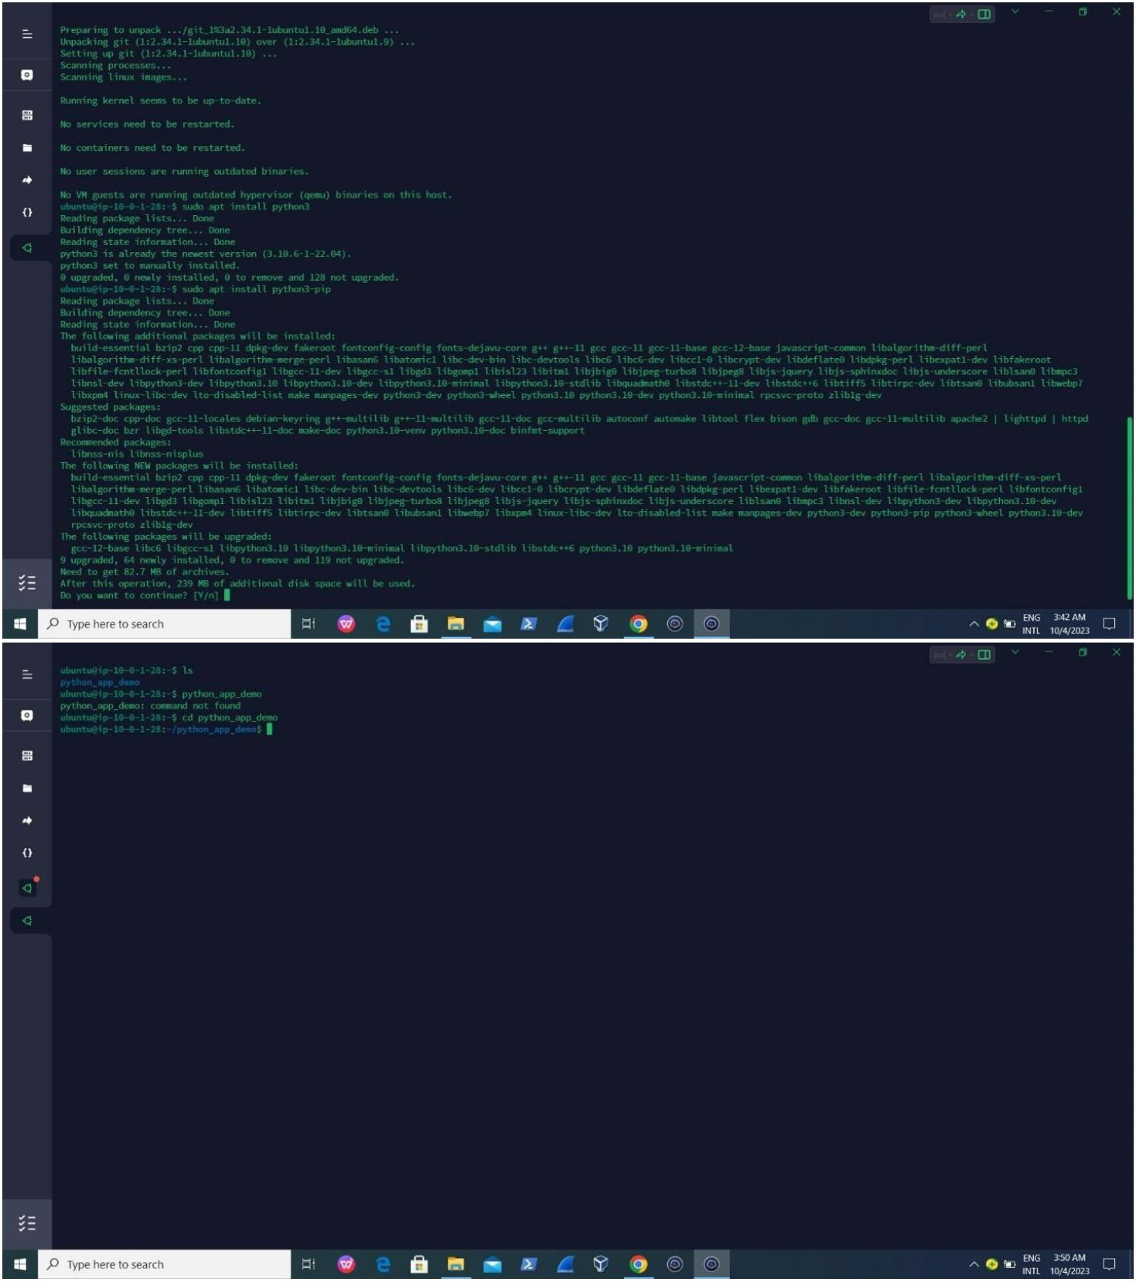

The next thing I did is that I go to my git repositories to copy the link I want to save up the ﬁles unto my

Os, then I copy the link and

Press git clone hꢂps://github.com/Spidy20/InNews.git to make it available on my AWS EC2 OS on my

terminus

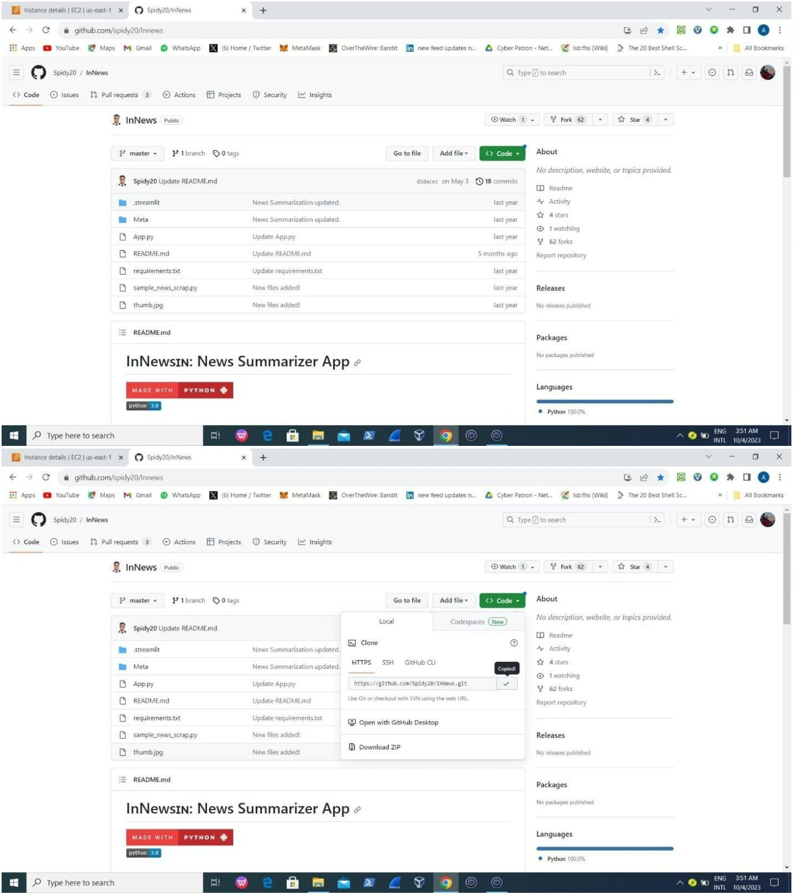

And I then ls to see what is it composed of

Aꢀer that, I moved on to my AWS EC2 SECURITY GROUP TO ACTIVATE THE PORT NUMBER IN WHICH THE

WEBSITE APP CAN OPERATE WHICH PORT 8501

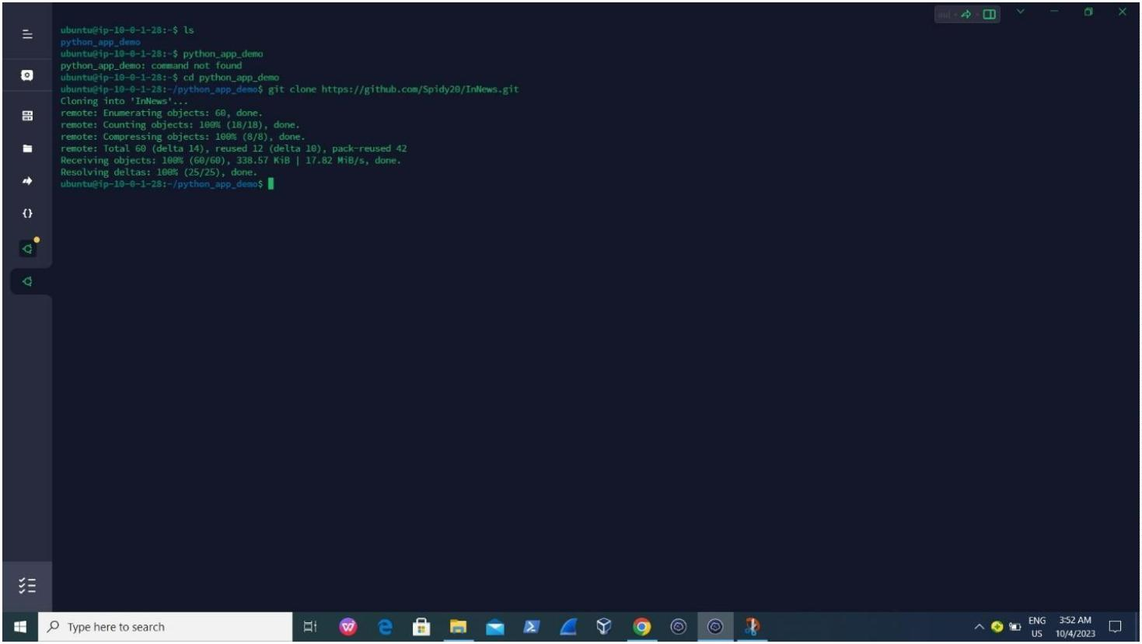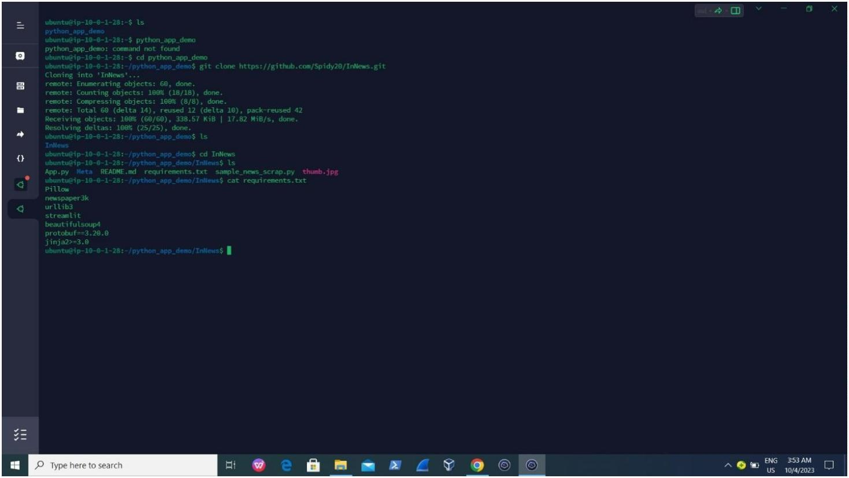

Aꢀer that, I go back to my aws ec2 os to run the deployment services but before then , an instrucrꢁon

was given to me by the developers when it comes to deployment…

In which he told me to run some command before I deploy it “pip install -r requirements.txt” Aꢀer

running it then I go for the website deployment

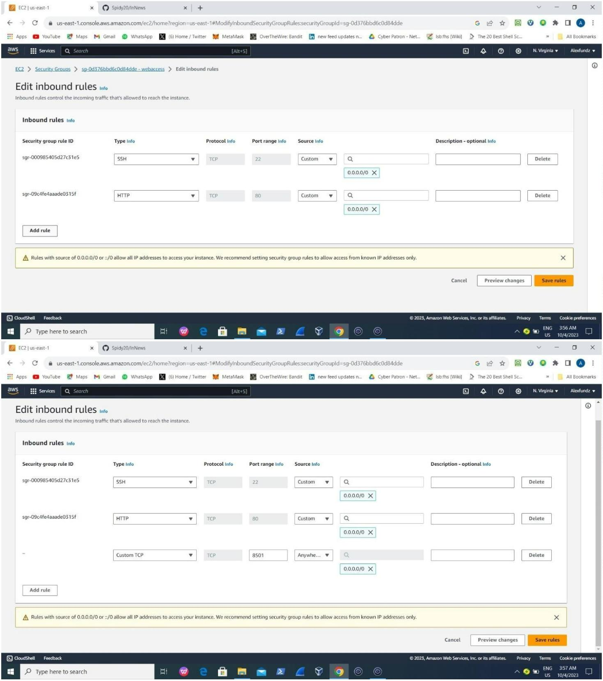

I deploy it by running “nohup python3-pip streamlit run App.py”

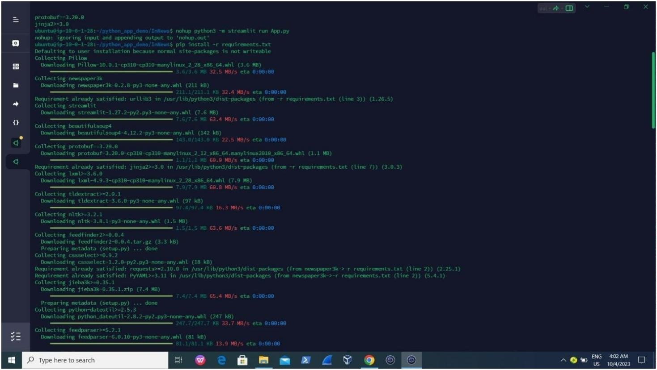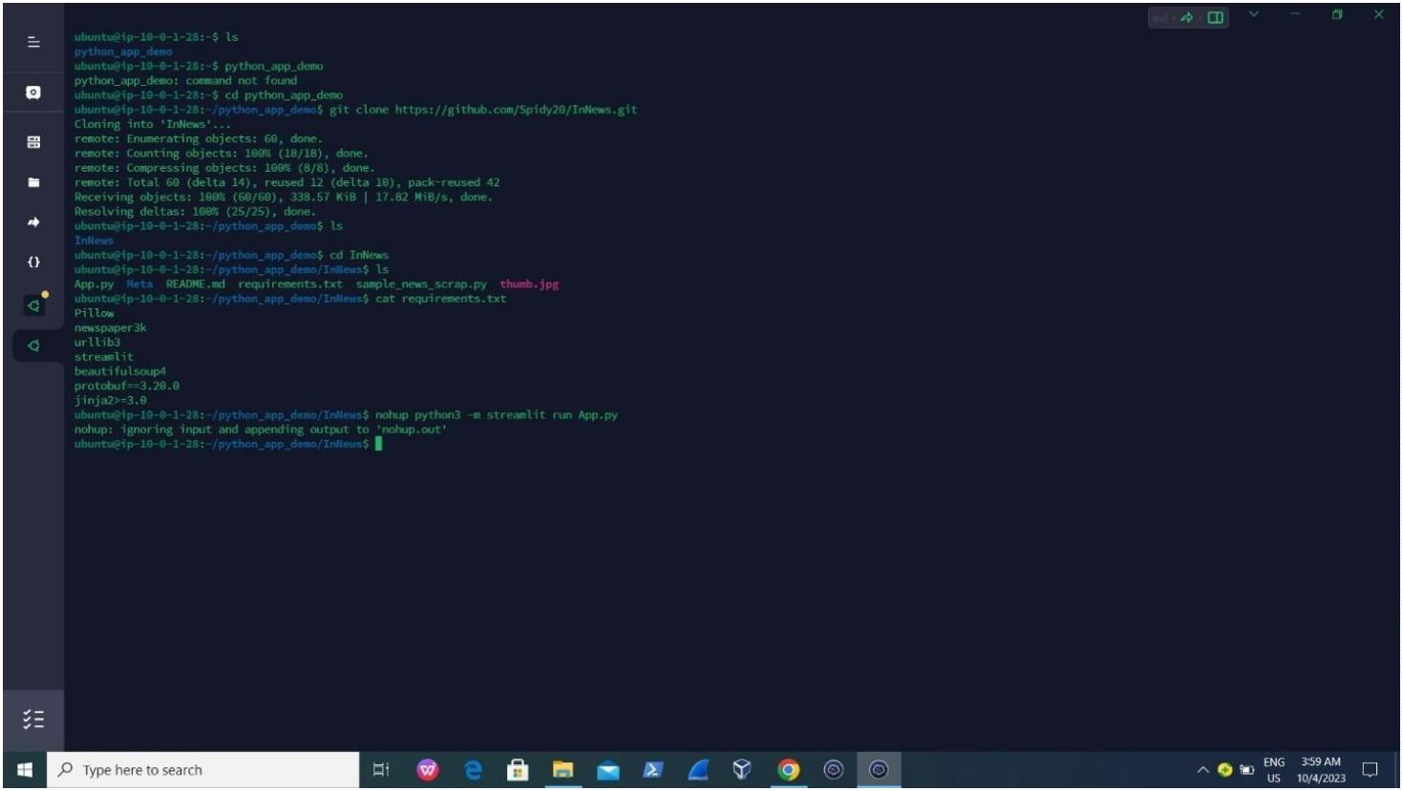

Then I tried to copy the Public address to my web page to check if it is live by running

“52.91.105.100:8501” and it works

THAT IS ALL ABOUT DEPLOYMENT OF PYTHON_APP

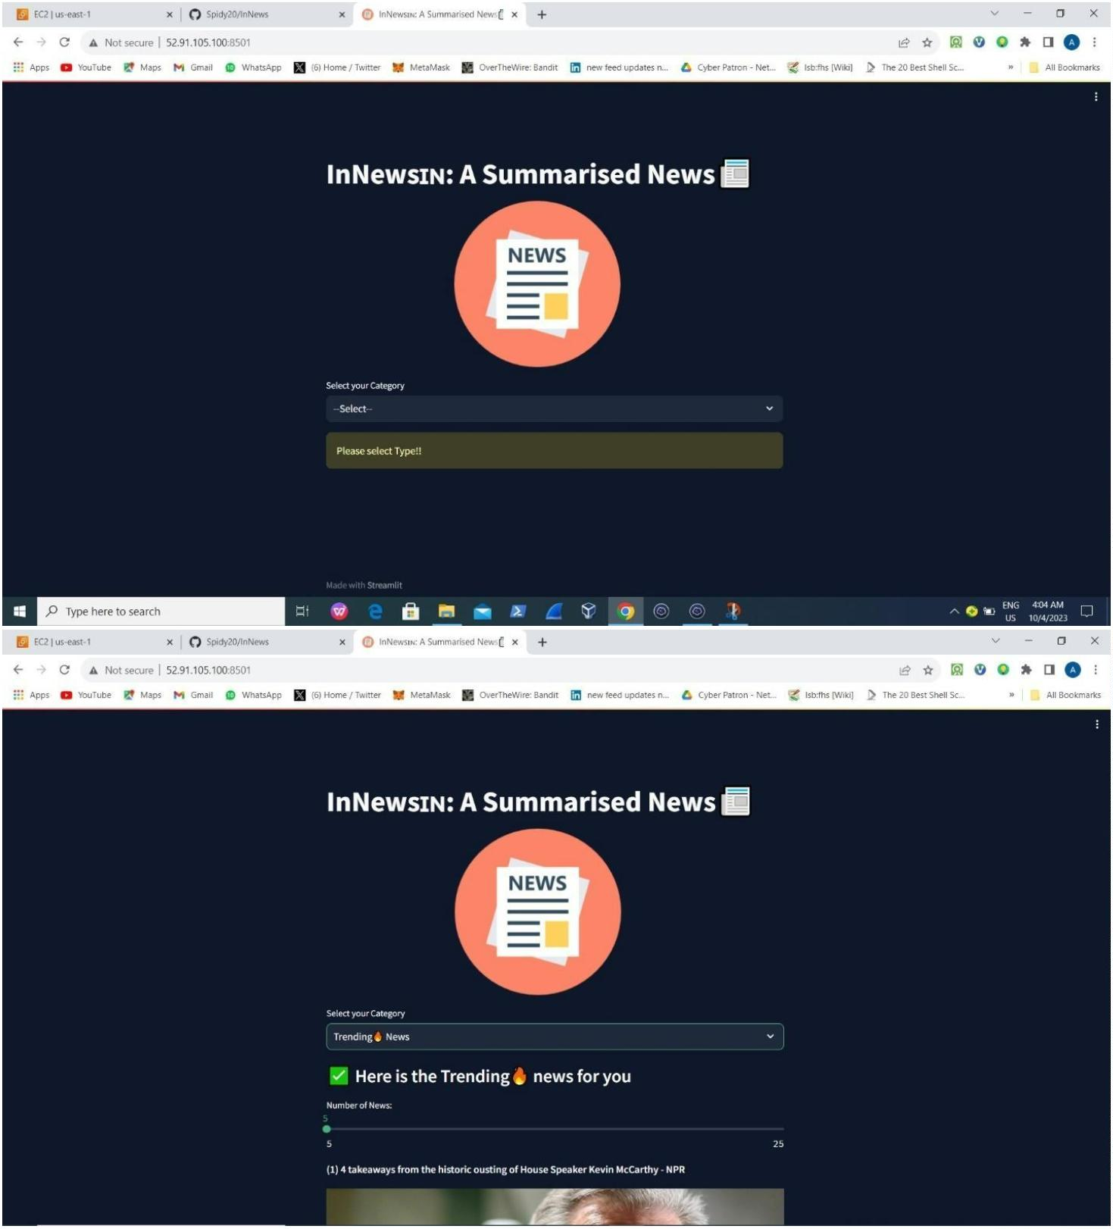

Thanks